The World of Kindle



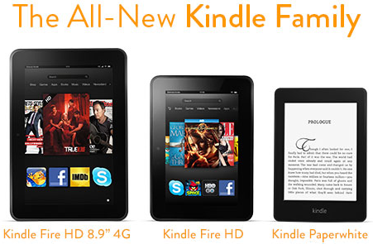

Nengjun Zhao John Procyk Bolun Zhang Jennifer Meidl Steve Steel

We Represent Amazon. Since the late 2000’s e-readers have become the next big thing for readers everywhere. In 2007 Amazon introduced the Kindle. Since then many versions of the Kindle have been introduced in the market and taken its competitors by storm.

**Team Amazon**

**BIA660- Web Analytics**

**Spring 2013**

**March 5, 2013**

**The Kindle Family**

Since 2007, Amazon has launched several different Kindles all providing different options for their readers.

The Original Kindle with e-ink is WIFI only, screen size is 6”, and it provides 2GB on device storage with additional free cloud storage and costs about $69.00.

The Kindle Keyboard comes in WIFI and 3G, has 6” screen, provides 4GB on‑device storage with additional free cloud storage and costs about $139.00.

Kindle PaperWhite 3G is an e-ink reader. It’s their 5th generation Kindle and has an internal evenly lit light source, also comes with WIFI capability, screen size of 6”, provides 2GB on‑device storage with additional free cloud storage and costs about $179.00.

Kindle Fire was their first entry into the tablet market, has a 7” LCD screen, is WIFI only, and comes with 8GB of on‑device storage with additional free cloud storage and costs $159.00.

Kindle Fire HD has a 7” HD LCD screen, dual band antenna with 3G and WIFI capabilities and can be purchased with up to 64GB of on-device storage. Cost is $199.00.

**Data Collection**

We obtained our data from multiple websites. These included amazon.com, sears.com, walmart.com, radioshack.com, j&r music world, b&h photo video, eBay.com, and sony.com. The bulk of our reviews were collected from amazon.com. Over 70,000 reviews were collected from Amazon.com, and far fewer (totaling around 300 reviews) from the other sites.

We created a Python script that extracted the data from our various websites and pushed it to an SQL database, (MySQL). Views were created in MySQL to pull compiled reports from the server. The downloaded data was then pushed to Excel for further analysis.

**Observations**

With the data we collected we narrowed the visualizations into 2 categories: monthly high sentiment (4 or 5 stars) and the monthly number of reviews for Amazon’s Kindle Family. The time period our data will focus on is October 2012-February 2013. It should be noted at this point that actual sales figures for the Kindle e-readers have never been released. We are assuming the number of reviews to be proportional to sales and are using the terms interchangeably.

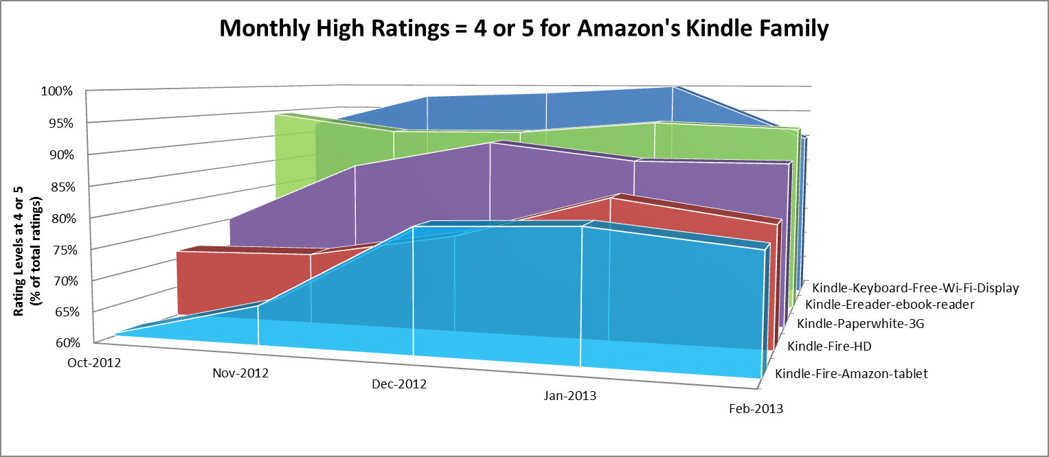

As you can see by the chart above, In October 2012 the Original Kindle scored 94.4% in 4 & 5 star ratings, the Kindle Fire scored 60.4%, Kindle Fire HD scored 71.4%, Kindle Keyboard scored 91.7%, and Kindle Paperwhite scored 75.1%. At this point the newly released Kindle Fire HD was already cannibalizing the sales of the Kindle Fire. Due to delays and problems in production, the Kindle Paperwhite’s satisfaction ratings were limited to an average of 75%.

In November 2012 their dedicated e-readers (the Kindle e-reader and the Kindle keyboard) maintained 4 & 5 star ratings above 90%.

In December 2012 ratings for the Kindle Fire rose 13.5% which we suspect have a direct linkage to the rise in Holiday sales. If we can read the overall counts as being proportional to sales figures, it looks like the Kindle Fire HD and the Kindle Fire were big sellers, but not overwhelming favorites. In January 2013, the Kindle Keyboard with WIFI out-performed the rest of the Kindle family with 100% ratings 4 &5 stars. In February 2013, the original Kindle once again proved to continue to be the consumers’ favorite with the highest ratings, giving it a 90% in 4 & 5 stars.

In December 2012 the Kindle Fire’s positive sentiment rose almost 14% and received more than 3500 reviews. This is a direct result of holiday sales. The Kindle Fire HD in December of 2012 and January 2013 remained consistent in their sentiment levels. We can infer that the pre-Christmas distribution of sales is being reestablished. In February 2013 the Kindle PaperWhite and Kindle Fire HD received almost the same number of reviews but the PaperWhite proved to be more popular. (Positive sentiment for Kindle Fire HD 79.6% vs. Kindle Paper White 87.7%)

The dedicated eReaders seem to have a dedicated following: consumers who are not looking for a multi-purpose device, but just an eReader. The 4-5 Ratings for these devices are generally 10 or more points higher than the tablets. This is saying that when it comes to eReaders, Amazon is doing it right. There is still a market for the original Kindle, and those ratings are the highest of any of the other devices. Early reviews of the Paperwhite, introduced just before the holidays, were very good, but consumers found problems with blotchy screens and uneven lighting. This took its toll in early sales and limited holiday sales as well. They did not sell as well as the tablets during the holiday season, but after the holidays they maintained their pre-holiday status in the stable eReader class.

Amazon’s entry into the tablet arena has been troublesome. Early reviews were favorable, but consumers didn’t like the non-configurable home screen, the slow web browser, lack of camera, insufficient memory, and slow response. For $200, it is a very good device, but severely lacking compared to full-featured tablets on the market.

The spikes in Holiday sales for the Kindle Fire and Fire-HD say that this was a great purchase for gift-giving. It is a very good device for children and an entry-level tablet, ideal for the holidays. It was somewhat surprising that, given the pre-holiday sentiment ratings, the sales would have been so much higher than the newer Fire-HD. The $40 premium of the Fire-HD might have been the reason the Fire-HD didn’t have greater sales as gifts.

After the Holiday season (January and February) the levels of sales came down to pre-holiday levels. The Fire-HD sales were nearly identical to November’s and the Fire’s sales dropped to less than half of Holiday sales. There seems to be a recognition that the Kindle Fire and Fire-HD are ideal as gifts, but purchasers looking for tablets of their own are doing their homework and recognizing that the shortcomings of Kindle tablets don’t put them in the same class as the iPad or Galaxy devices. Still, the Amazon Kindle devices have very high ratings and they are approved of by great numbers of consumers.

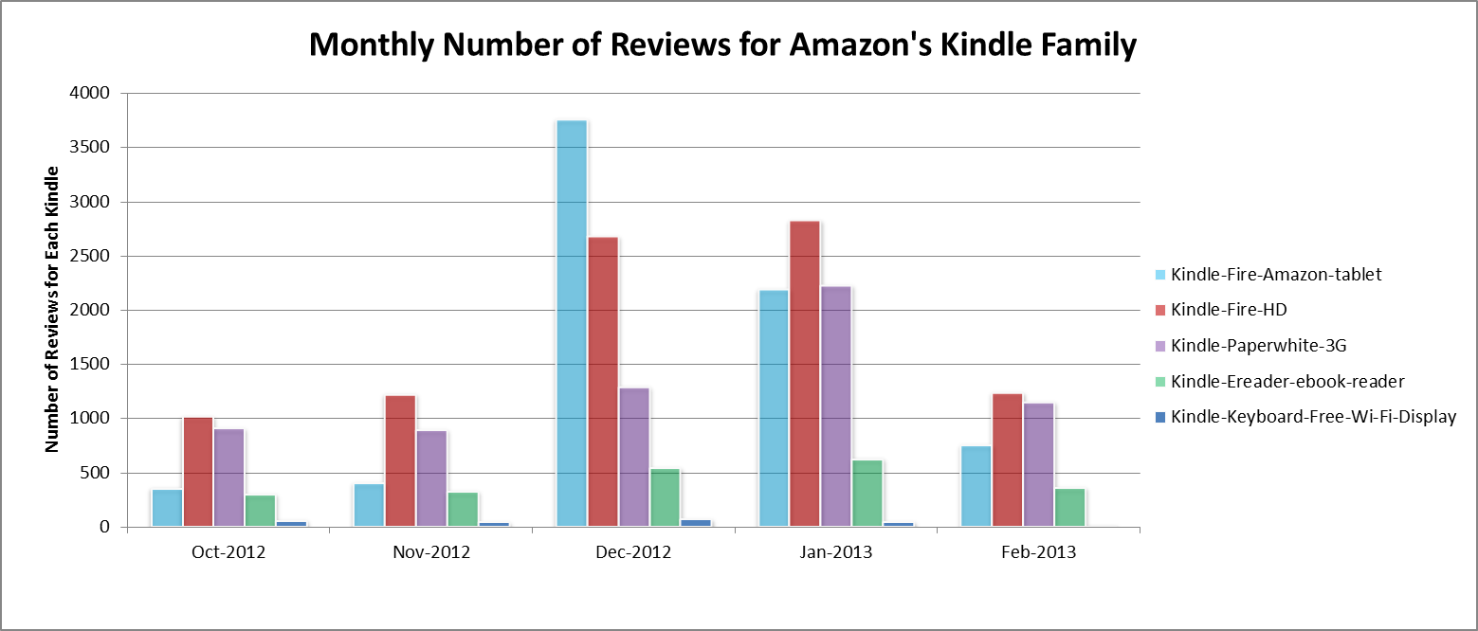

**Our Conclusions**

Our data analysis indicates a high degree of positive customer sentiment (measured by % of customers giving ratings of 4 or 5 stars) and satisfaction across the dedicated e-readers. There is a segment of the population that prefers a dedicated e-reader over multi-purpose devices. The tablet-based Kindles trail in sentiment but are attractive in cost. With Amazon, most of their own products have been cannibalized by the entry of another member of their Kindle family.